Week 3: Seller and Inventory Management System
Scenario:
The e-commerce company wants to maintain information about customized gifts and their categories.
Each product belongs to a specific category, and the system manages product details such as product name, price, and stock availability.
The main categories include Birthday Party, Anniversary, Baby Shower, Wedding, Housewarming, and Graduation.
1.create Seller and Inventory Tables
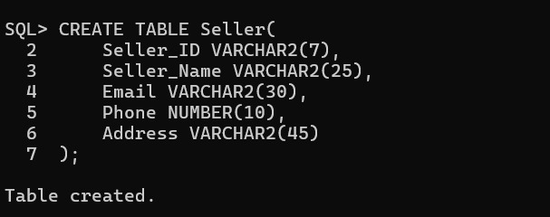
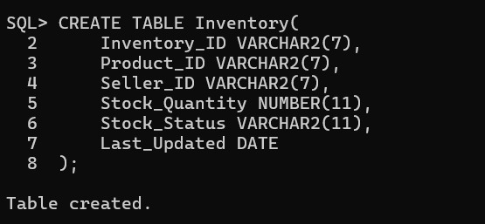
2. Establish Relationships
Seller and Product
One seller can supply multiple products.
One product can be supplied by one or multiple sellers.
Relationship:
Seller → Product is One-to-Many
Product and Inventory
Each product has inventory information.
Inventory tracks available stock.
Relationship:
Product → Inventory is One-to-One
Primary Key added for Both Tables:
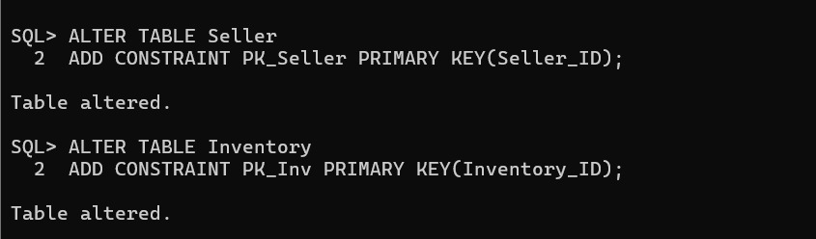
Foreign Key for Inventory Table:
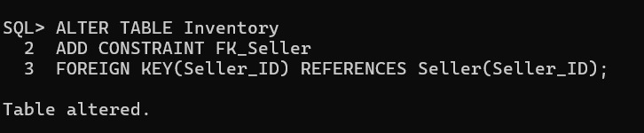
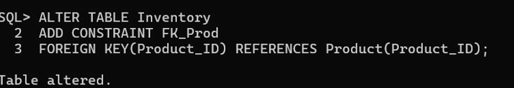
Constraints to make Unique Email ID:
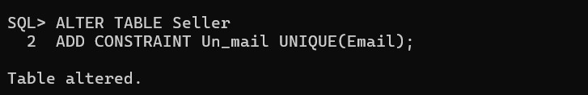
To make Email NOT NULL 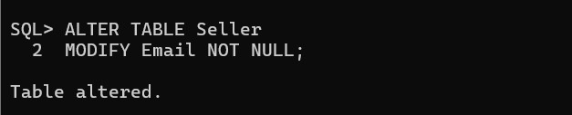
Add Constraint to Check the Stock Quantity is Positive
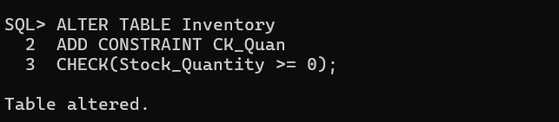
Insert Values to Seller Table
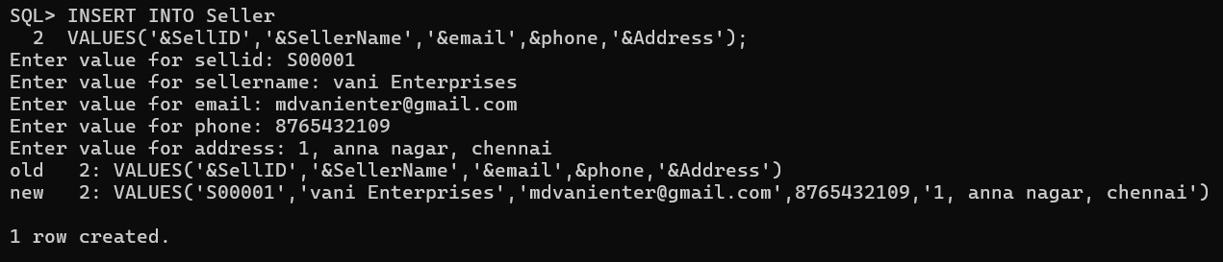
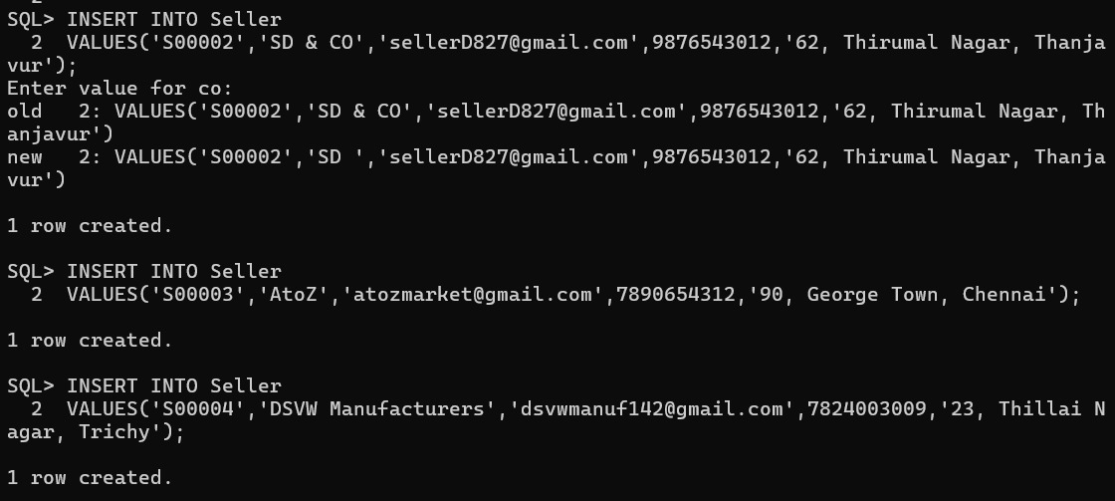
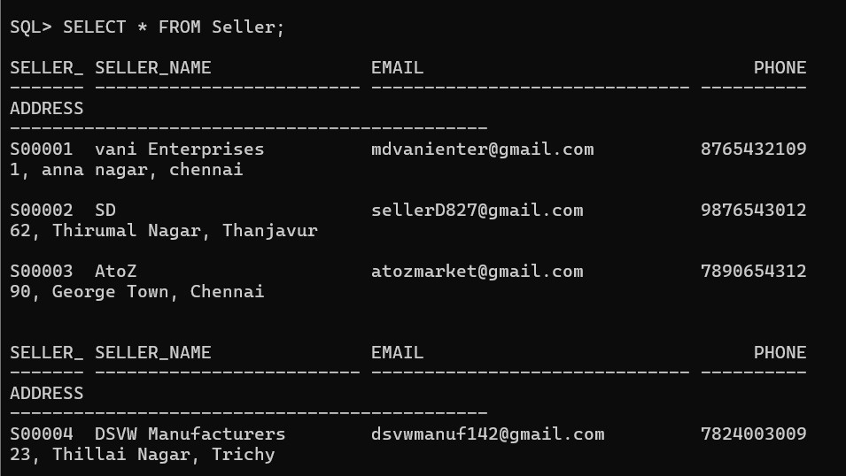
Insert Values to Inventory Table
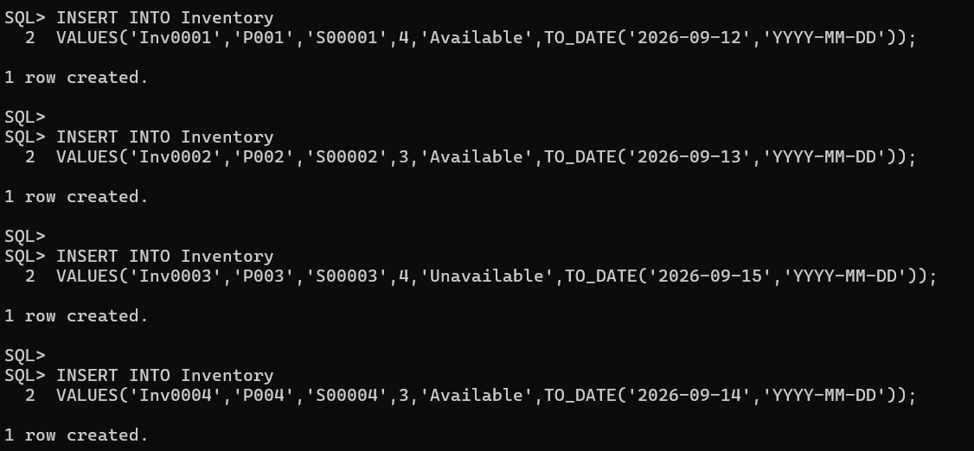
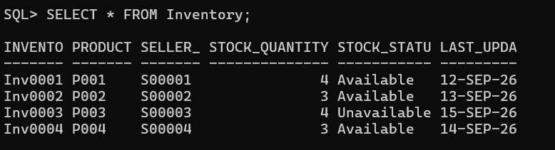
Report 1: Seller-wise Product Report
Display:
- Seller name
- Number of products supplied
- Available stock
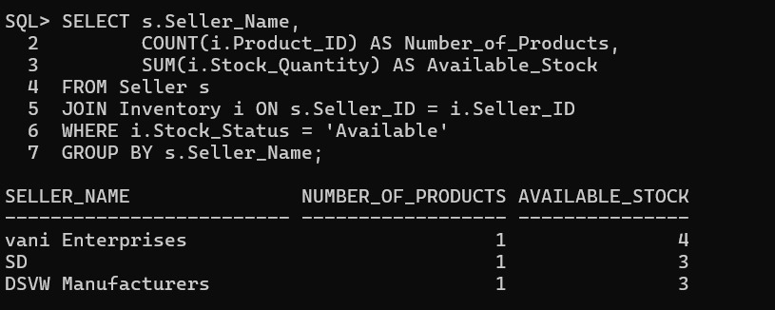
Report 2: Stock Availability Report
Display:
- Product name
- Stock quantity
- Stock status
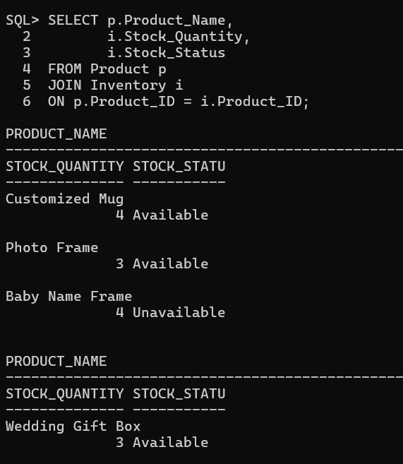
Report 3: Inventory Analysis
Find: Total products available 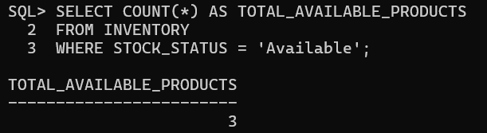
Products out of stock
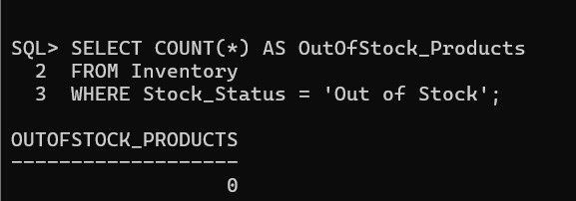
Highest stocked products 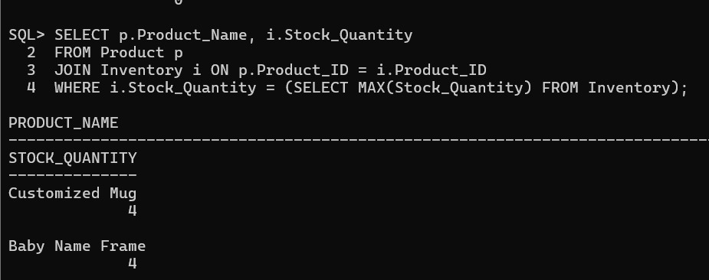
Average inventory quantity
